**SRI MUTHUKUMARAN ARTS AND SCIENCE COLLEGE**

**(Affiliated to university of Madras)**

**CHIKKARAYAPURAM, CHENNAI- 600 069.**

**DEPARTMENT OF MATHEMATICS**

**Under scheme of**

**NAANMUDHALVAN**

**Project Title: Unearthing the Environmental Impact of Human Activity:**

**A Global CO2 Emission Analysis**

**Submitted By**

**Keerthana.R**

[**keerthanaraja1628@gmail.com**](mailto:keerthanaraja1628@gmail.com)

**Sandhiya.M**

[**msandhiya436@gmail.com**](mailto:msandhiya436@gmail.com)

**Team Id: NM2023TMID01241**

**Under the mentor of**

**Poobalan . N**

[**Balanpoo36@gmail.com**](mailto:Balanpoo36@gmail.com)

**Department of Mathematics**

1. **INTRODUCTION**
   1. Overview

The analysis should determine the exclusive global amount of carbon dioxide and other greenhouse gases accumulated over the full lifecycle of a product, service, or operation. Green plants grow faster with more co2. Many also become more drought resistance because higher co2 levels allow plants to use water more efficiently.

1.2 Purpose

The carbon in co2 can be used to produce fuels that are in use today, include methane, methanol, gasoline and aviation, fuels the primary sources of greenhouse gas emissions are electricity and heat 31%, agriculture 11%, transportation 15% , forestry 6% and manufacturing 12% . Energy productions of all types accounts for 72 % of all emissions.

**2. PROBLEM DEFINITION AND DESIGN THINKING**

**2.1 Empathy Map**

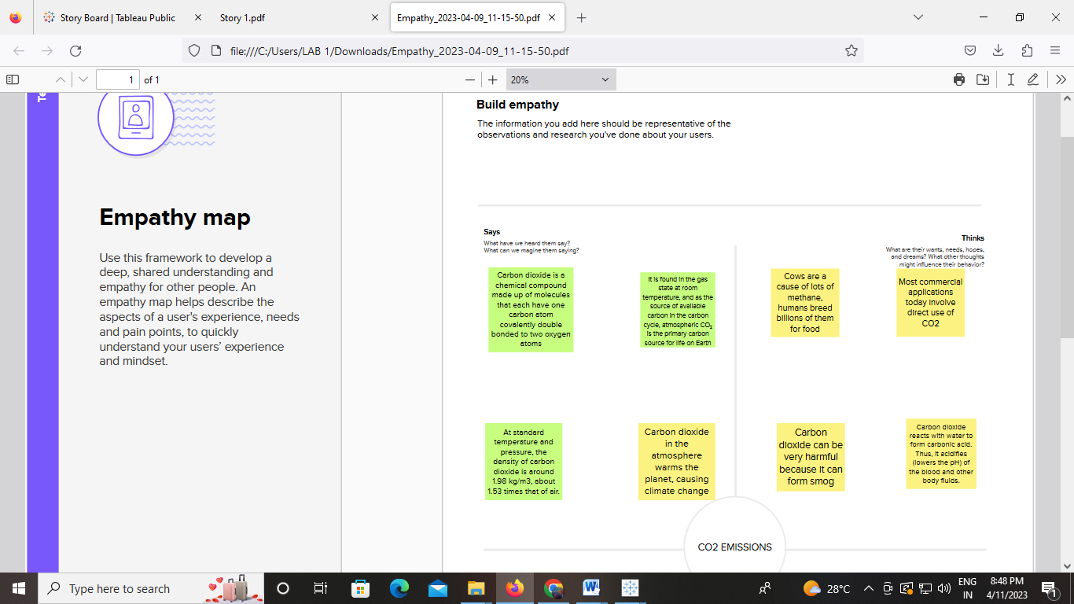

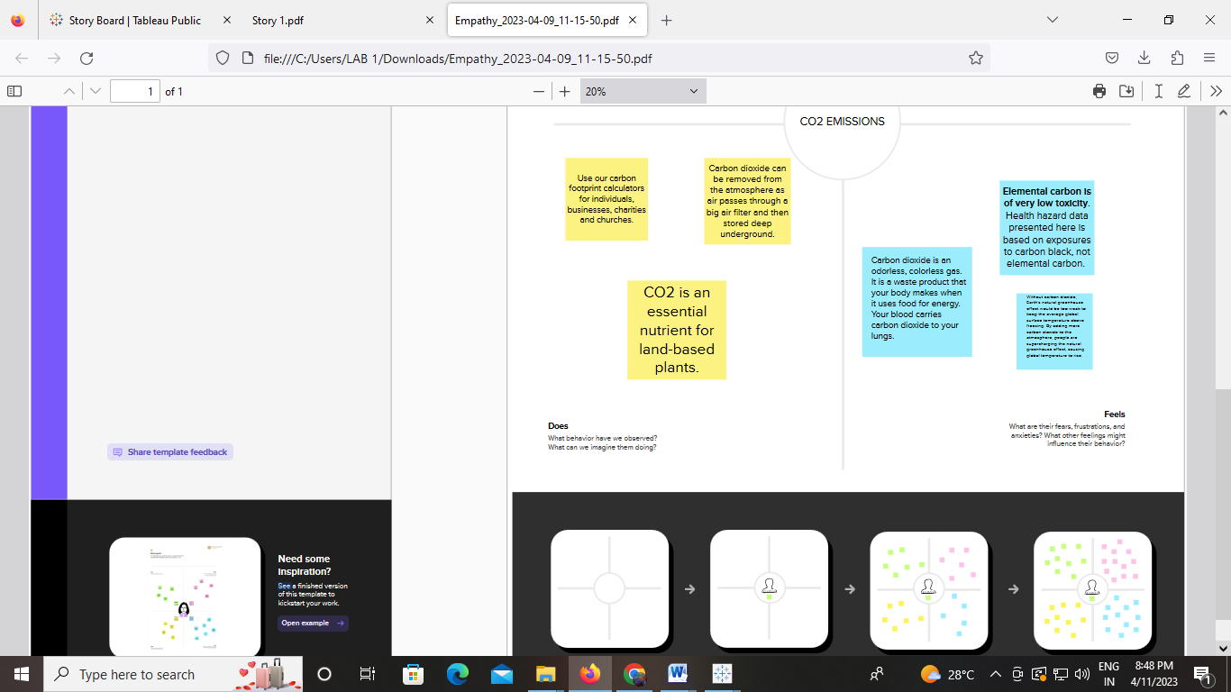

**Full Page screenshot**

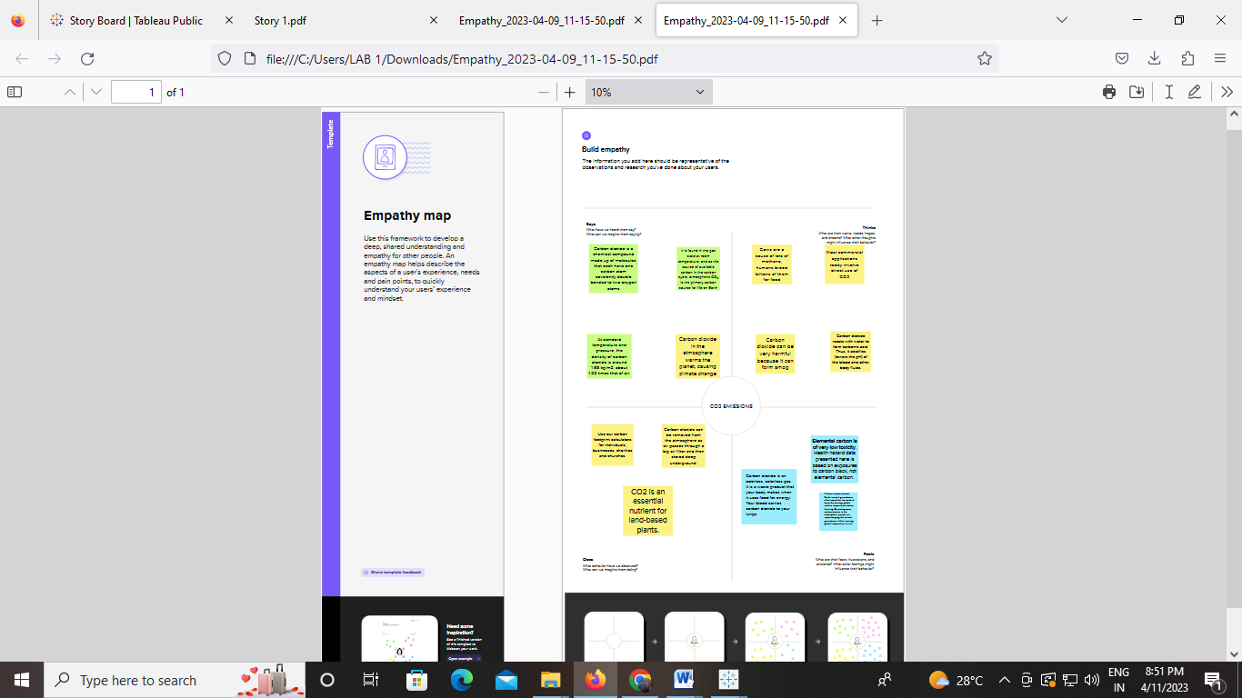

**2.2 Ideation and Brainstorming map screenshots**

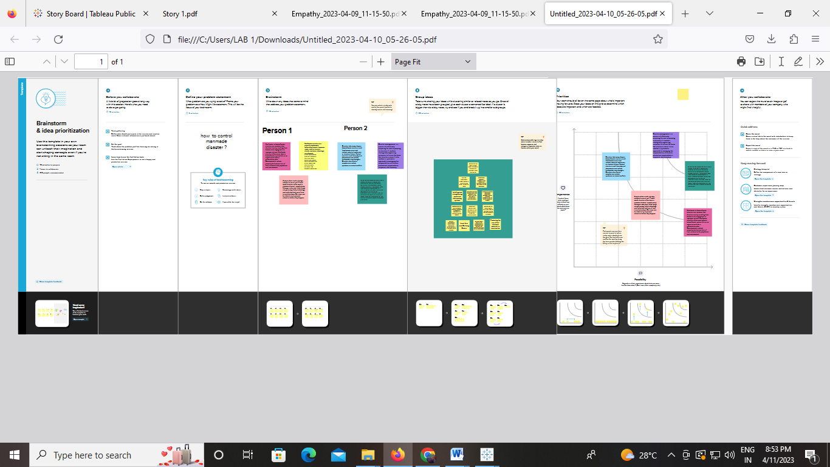

**3. Result**

**Dashboard . 1**

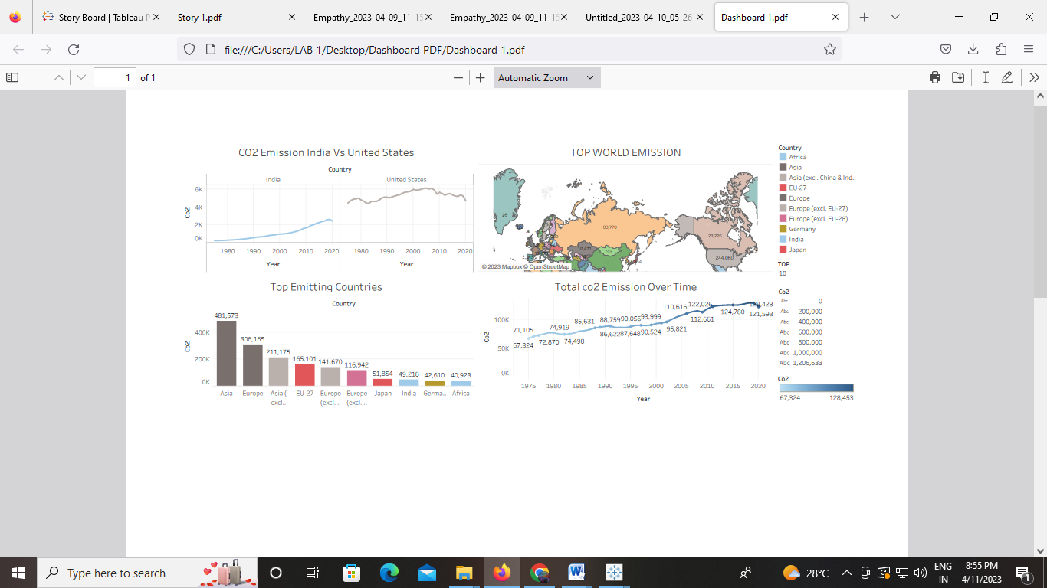

**Dashboard. 2**

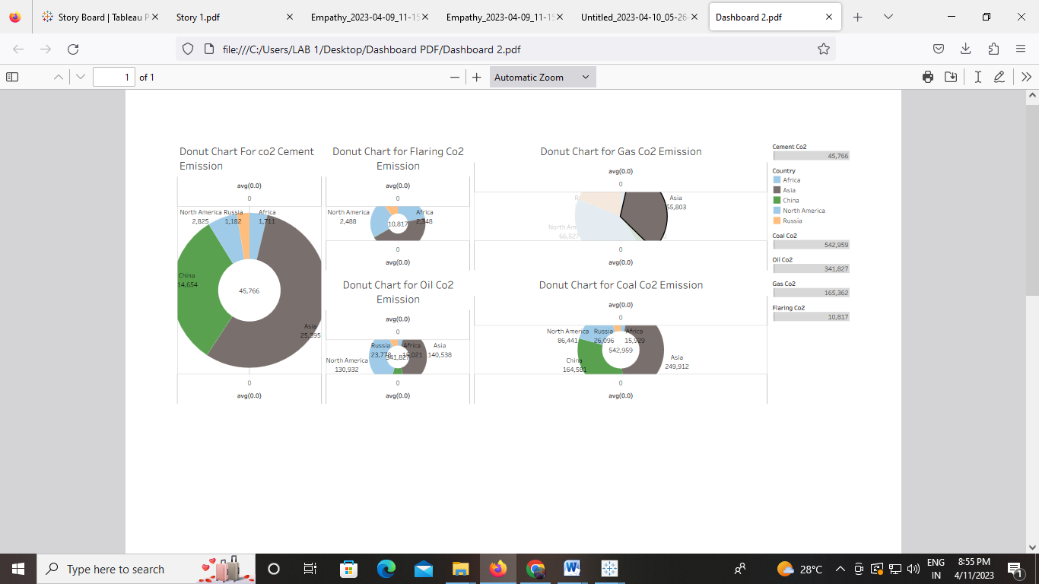

**Dashboard. 3**

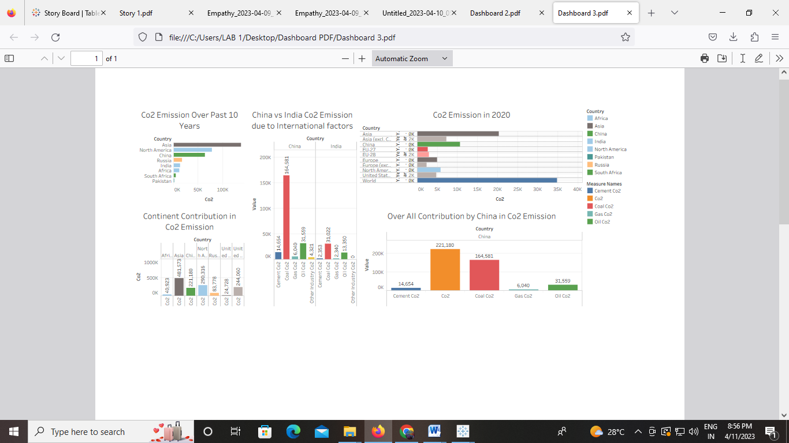

**Dashboard. 4**

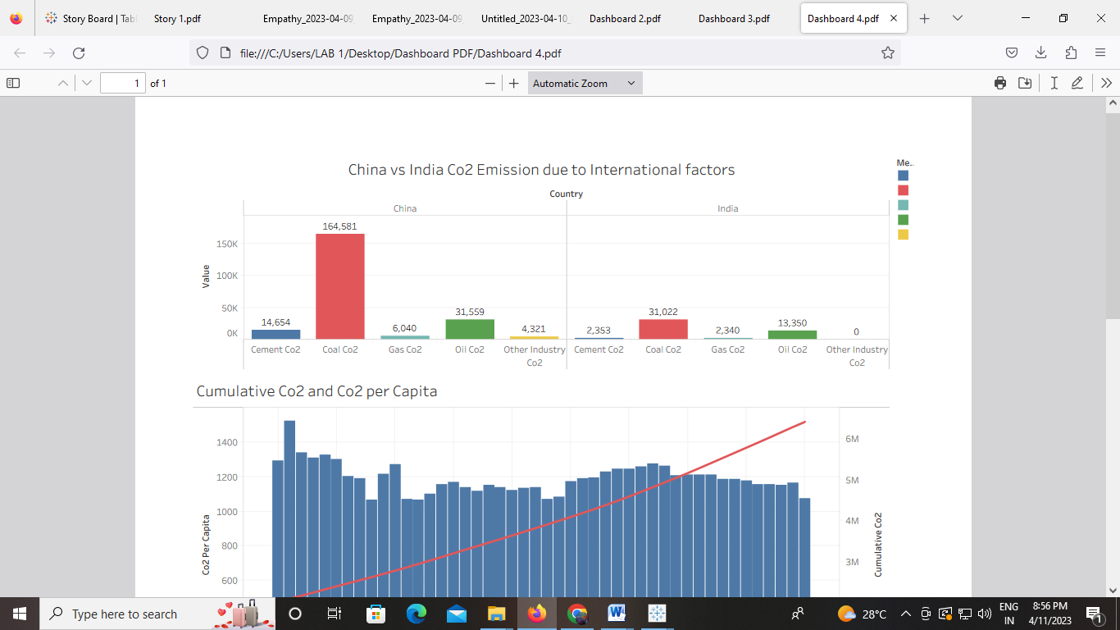

**Story board 1**

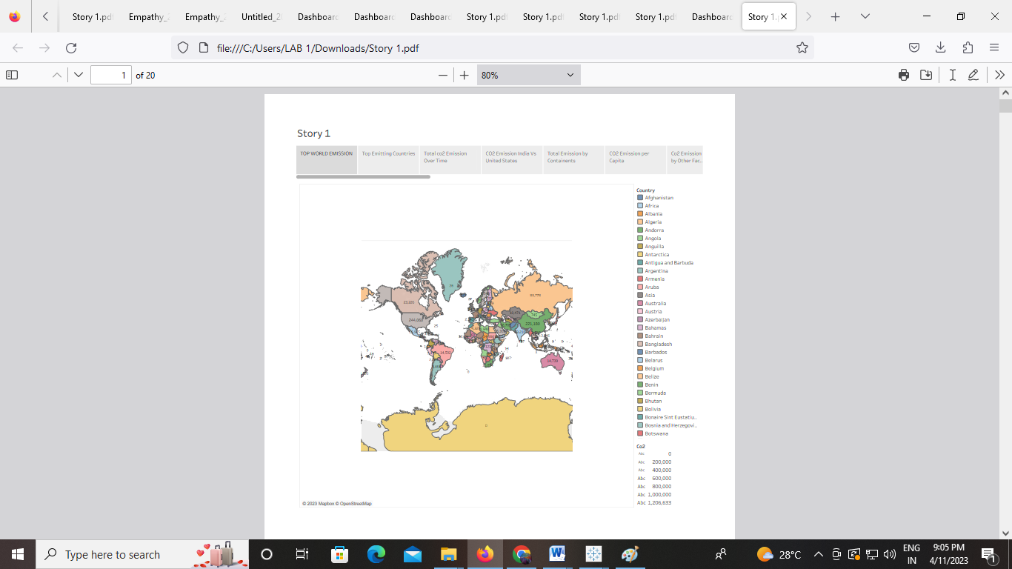

**Story board 2**

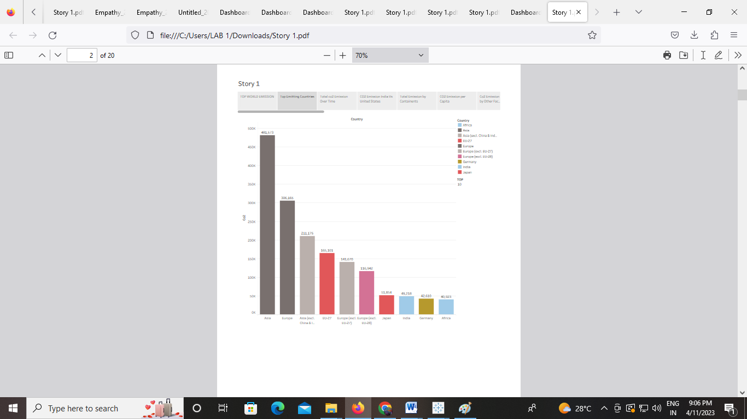

**Story board 3**

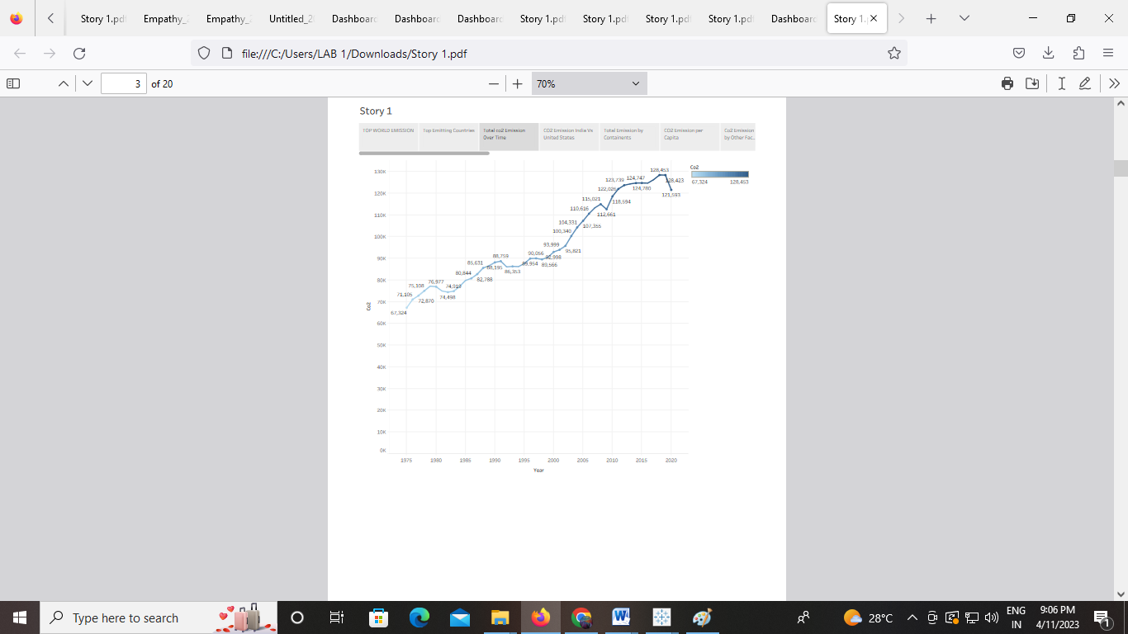

**Story board 4**

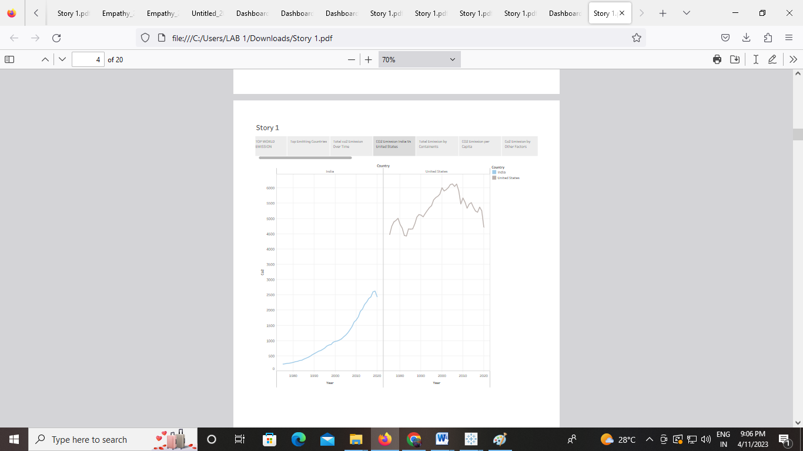

**Story board 5**

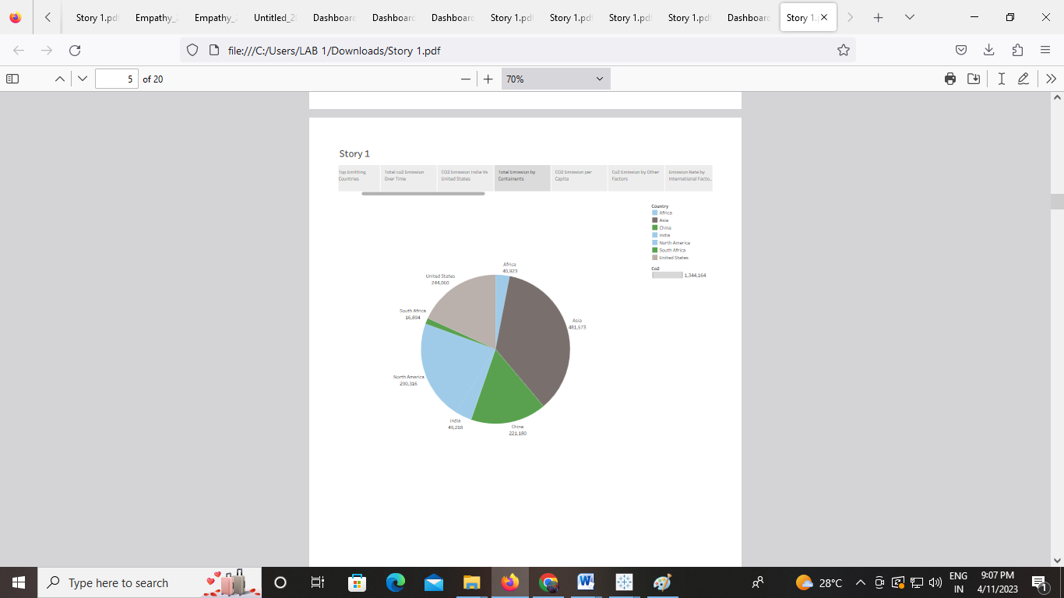

**Story board 6**

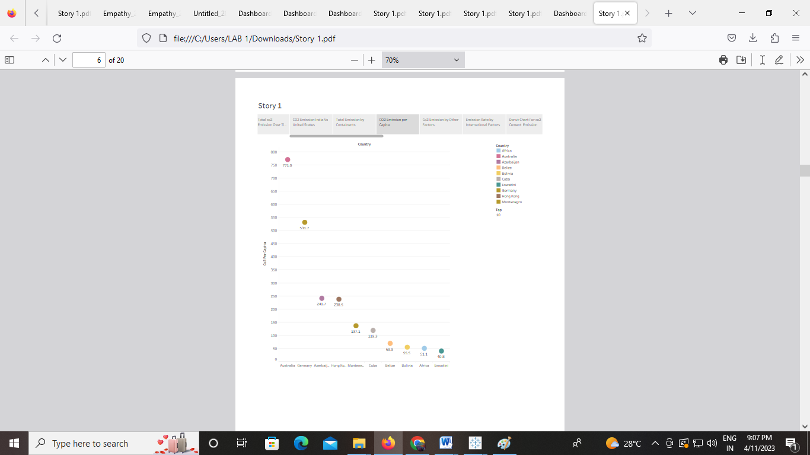

**Story board 7**

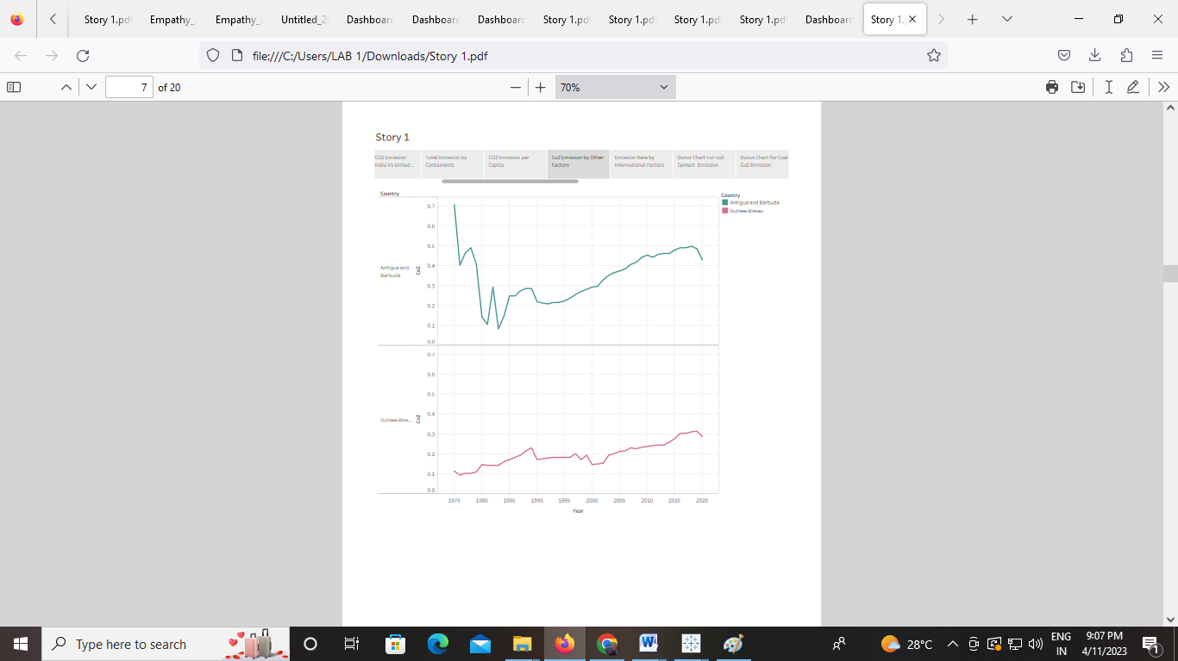

**Story board 8**

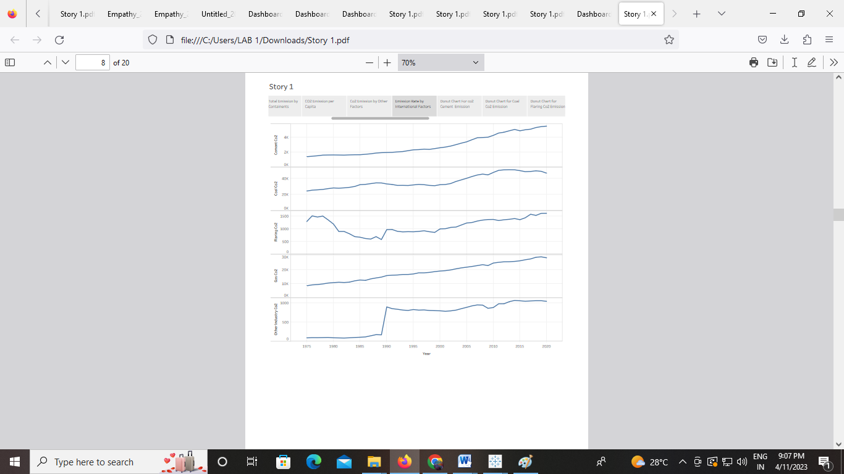

**Story board 9**

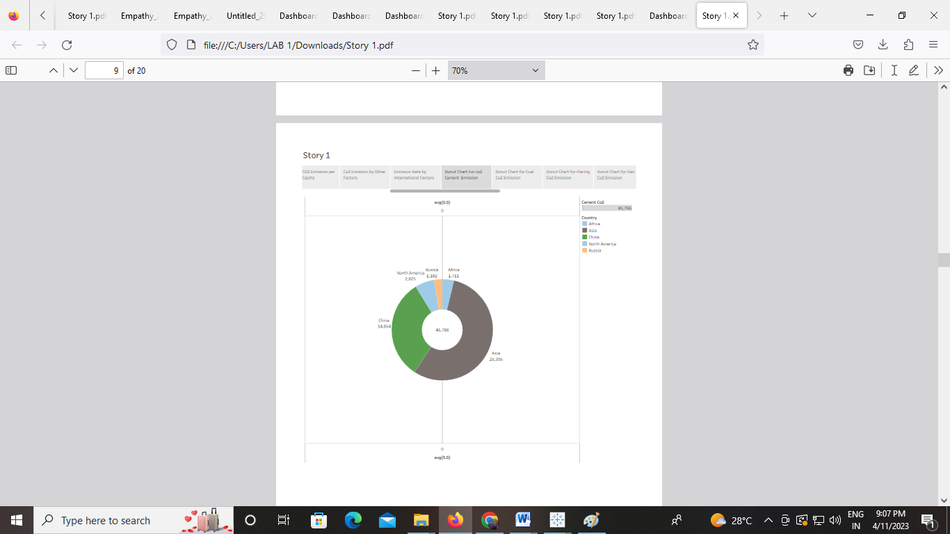

**Story board 10**

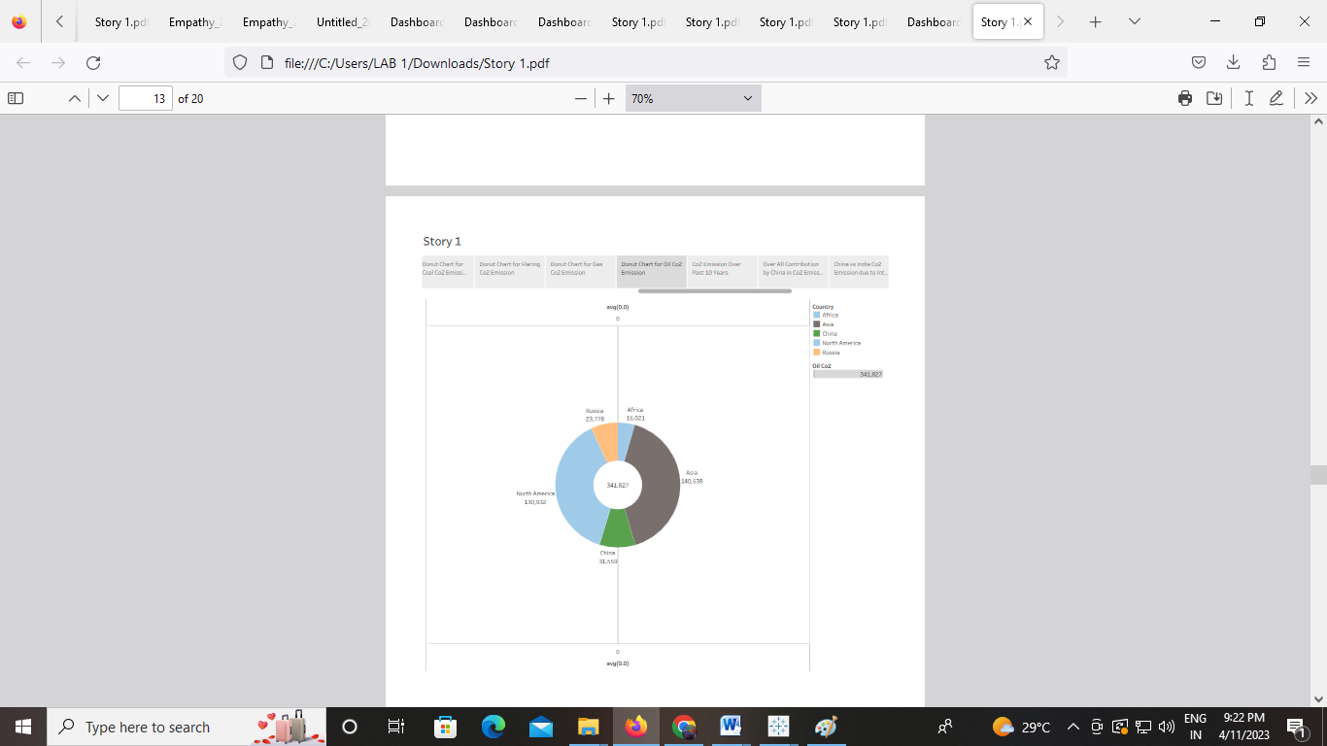

**Story board 11**

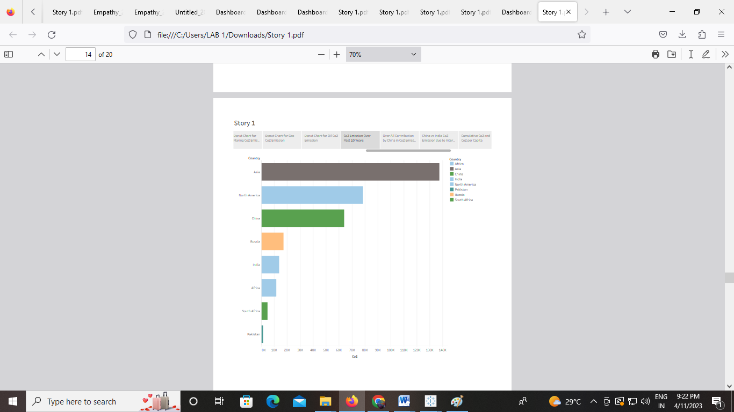

**Story board 12**

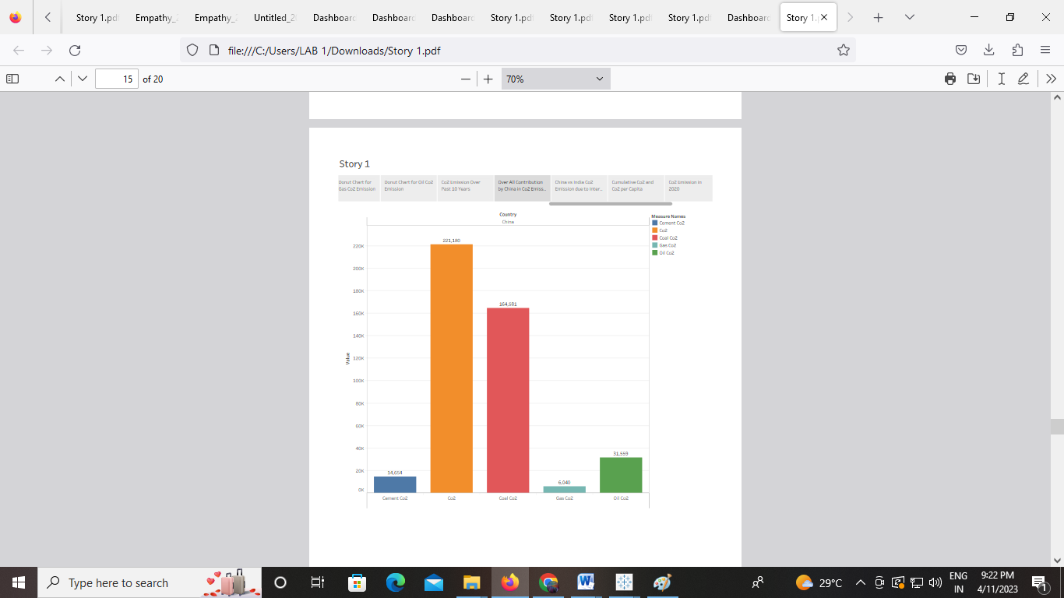

**Story board 13**

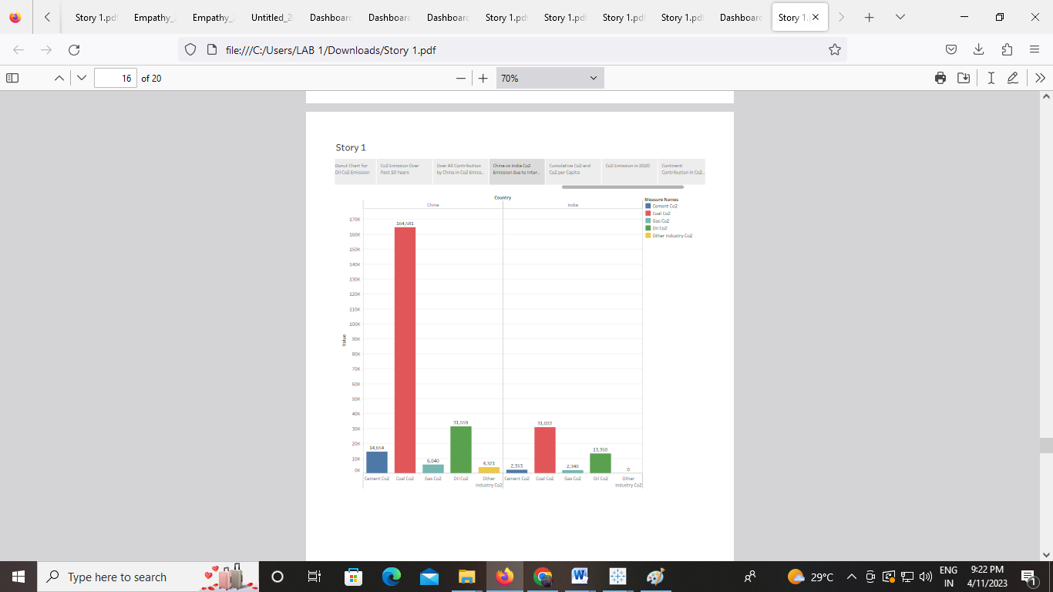

**Story board 14**

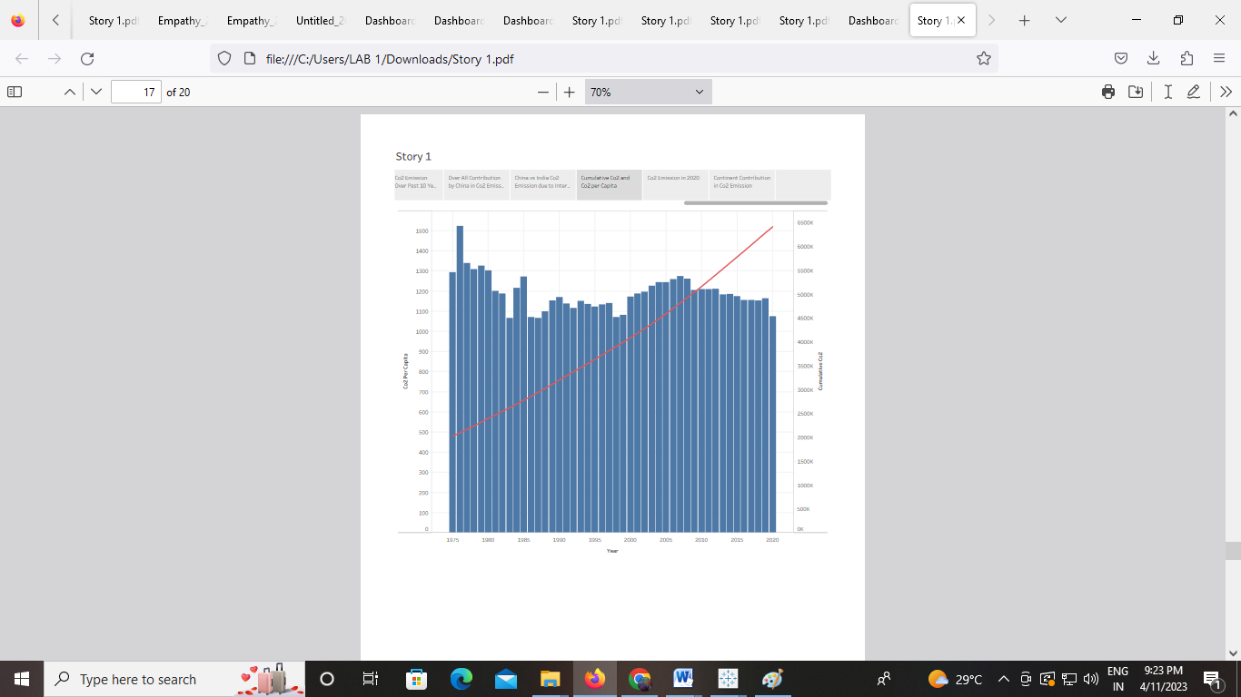

**Story board 15**

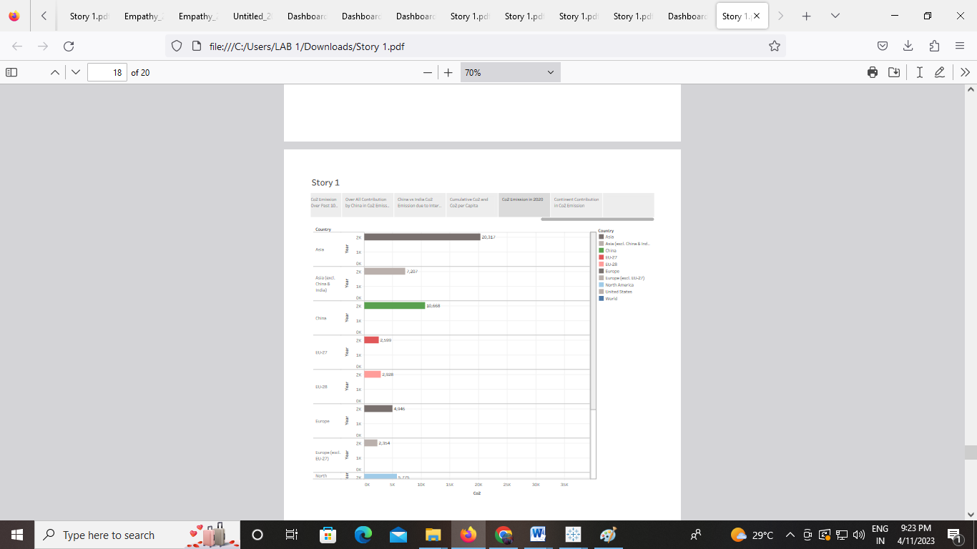

**Story board 16**

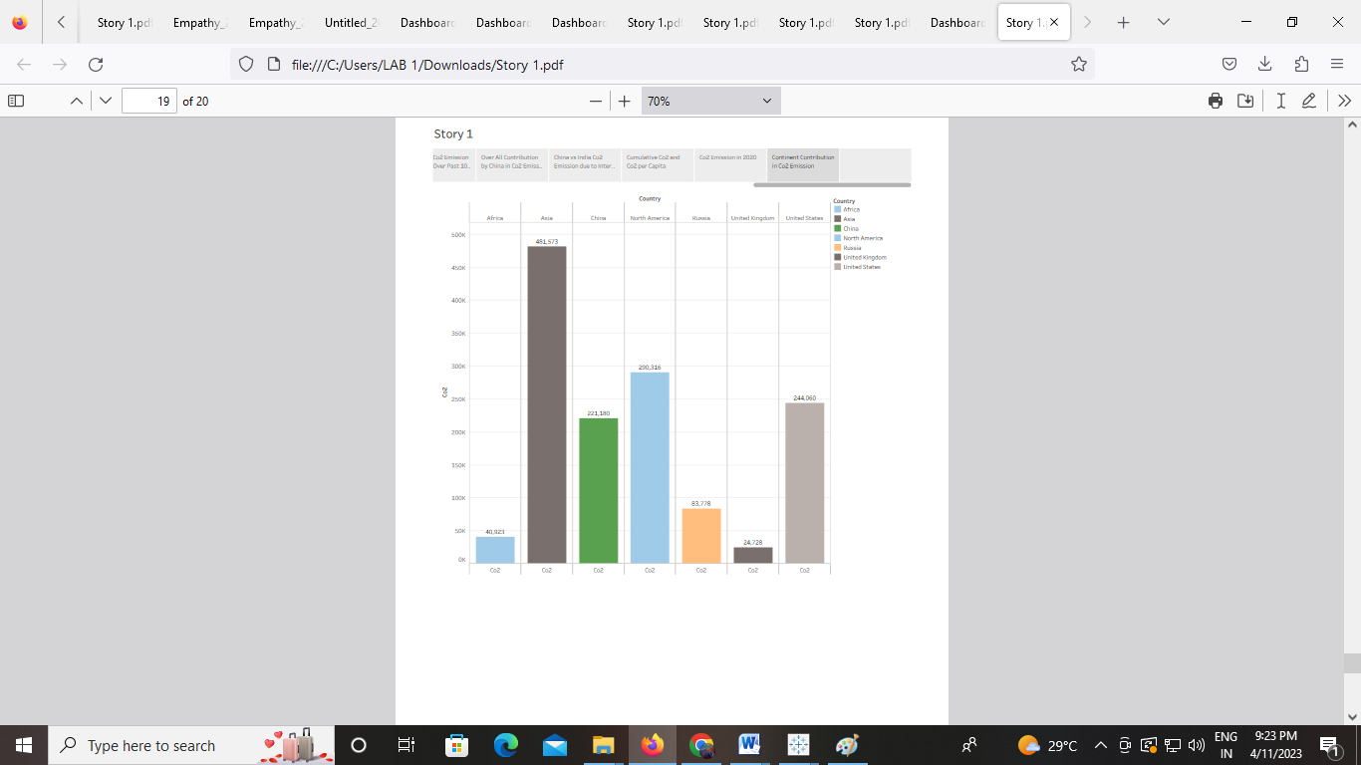

**4 ADVANTAGES AND DISADVANTAGES**

The carbon in CO2 can be used to produce fuels that are in use today, including methane, methanol, gasoline and aviation fuels. Future CO2 increases will boost agricultural productivity and improve drought resistance, thereby bolstering food security and contributing to a greener, lusher planet.

Reducing these co-emitted air pollutants improves air quality and benefits human health. It would be impossible for life on earth to exist without carbon. Carbon is the main component of sugars, proteins, fats, DNA, muscle tissue, pretty much everything in your body. The reason carbon is so special is down to the electron configuration of the individual atoms.

Carbon is used by plants to build leaves and stems, which are then digested by animals and used for cellular growth. In the atmosphere, carbon is stored in the form of gases, such as carbon dioxide.

**DISADVANTAGHES:**

Carbon emissions affect the planet significantly, as they are the greenhouse gas with the highest levels of emissions in the atmosphere. This, of course, causes global warming and ultimately, climate change. This change in concentrations causes warming and is affecting various aspects of climate, including surface air and ocean temperatures, precipitation, and sea levels. Human health, agriculture, water resources, forests, wildlife, and coastal areas are all vulnerable to climate change without carbon dioxide, Earth's natural greenhouse effect would be too weak to keep the average global surface temperature above freezing. By adding more carbon dioxide to the atmosphere, people are supercharging the natural greenhouse effect, causing global temperature to rise. Warmer temperatures can cause economic losses for a country through many pathways, such as lowering agricultural yields, reducing labour productivity, and decreasing industrial output.

**5 APPLICATION :**

**Area : INDIA**

Using fuels that emit less CO2 than fuels currently being used. Alternative sources can include biofuels; hydrogen; electricity from renewable sources, such as wind and solar; or fossil fuels that are less CO2-intensive than the fuels that they replace. Alternatives to driving . When possible, walk or ride your bike in order to avoid carbon emissions completely. Carpooling and public transportation drastically reduce CO2 emissions by spreading them out over many riders. Drive a low carbon vehicleHigh mileage doesn't always mean low CO2 emissions.Stop buying your water in plastic and we can use Biogas from Landfills. Landfills are designated locations for disposal of waste collected from residential, industrial, and commercial entities this is the alternative solution of co2.

**6 CONCLUSION**

"The rising level of atmospheric CO2 could be the one global natural resource that is progressively increasing food production and total biological output, in a world of otherwise diminishing natural resources of land, water, energy, minerals, and fertilizer."  Carbon capture and sequestration is an attractive option for reducing greenhouse gas emissions and could even help remove carbon dioxide from the atmosphere. By adding more carbon dioxide to the atmosphere, people are supercharging the natural greenhouse effect, causing global temperature to rise. Then the example map and various type of graph can help to analyse the percentage of co2 value.

**7 FUTURE SCOPE**

CO2 can also replace fossil fuels as a raw material in chemicals and polymers. Less energy-intensive pathways include reacting CO2 with minerals or waste streams, such as iron slag, to form carbonates for building materials. The future market potential for CO2-derived products and services is difficult to assess.